**Home Fun 19.10.2020**

**Task -1**

**Given are statement about happy and sad faces. Represent the statement by making those number of happy and sad faces.**

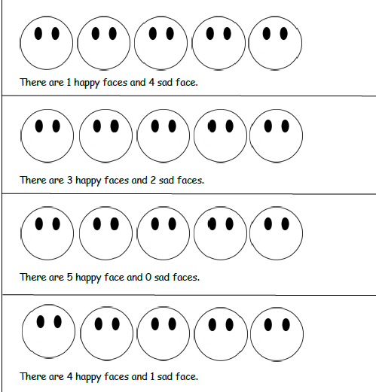

**Task -2**

**Read the words in the column. Cut and paste them in the**

**write word family ice-cream.**

